Omnican Report
LifeCanada

Canadians’ Opinion on Abortion

#10598-002
October 2003


507, place d’Armes, suite 700, Montreal (Quebec) H2Y 2W8  Tel. : 514-982-2464  Fax : 514-987-1960  www.legermarketing.com

Table of Contents

Table of Contents 2

Methodology 3

Detailed Findings 4
1. Moment When Life Begins 5
2. Point of Human Development when the Law Should Protect Life 7
3. The Use of Human Embryos in Stem Cells Research 9
4. Consent Laws on Abortion 11
5. Parents Consent For Abortion 12
6. Opinion of Canadians toward the Use of Public Funds for Abortions 14

Questionnaire 16

Methodology

This report is based on a survey conducted among a representative sample English- or French-speaking Canadians, 18 years old of age or older. In total, six (6) questions were inserted in Leger Marketing’s national omnibus survey.

In total, 1505 respondents were interviewed for the first three questions, and 1882 were interviewed for the last three questions. Using the latest data from Statistics Canada, the results were weighted according to region, gender and language spoken at home to ensure a sample representative of the entire Canadian adult population. The maximum margin of error for 1505 respondents is of ± 2.5%, 19 times out of 20, and the maximum margin of error for 1882 respondents is of ±2.3%, 19 times out of 20.

Note
In the tables, numbers in bold blue indicate a significantly higher proportion for the given sub-sample group; numbers in bold red indicate a significantly lower proportion.

Detailed Findings

1. Moment When Life Begins

While one-third of Canadians (32%) believe that their life began at conception, one-quarter (26%) believe that it began at birth. Slightly more than one-in-ten (12%) think that their life began sometime between conception and birth and slightly more than one-in-five (22%) think that their life began after birth.
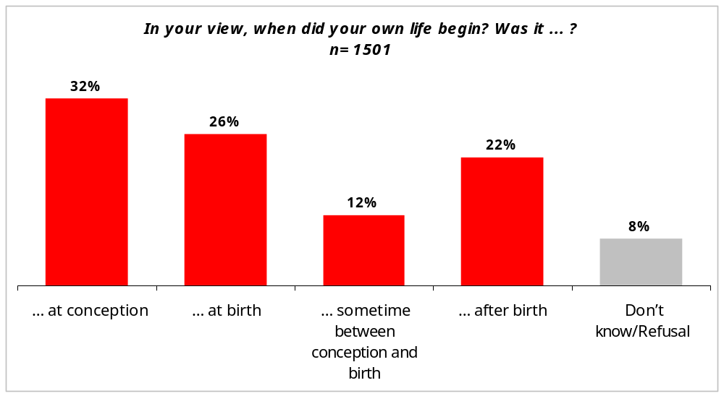

Respondents with the following characteristics are significantly more likely to believe that their life began…

- … at conception: women (37%), 35-44 yearolds (37%), respondents from the Prairies (41%) and homemakers (48%).

- … at birth: respondents aged 65 years or older (33%), retirees (48%).

- … sometime between conception and birth: 35-44 yearolds (15%), respondents from the Atlantic provinces (19%), respondents with an annual household income of $60K or more (15%), professionals (18%) and respondents with a university level of education (18%).
Results by Province

In your view, when did your own life begin? Was it ... ?

 | Total (n=1505) | Atl. (n=100) | Quebec (n=400) | Ontario (n=605) | Prairies (n=125) | Alberta (n=125) | B.C.  (n=150)
- … at conception | 32% | 29% | 32% | 33% | 41% | 35% | 27%
- … at birth | 26% | 20% | 26% | 29% | 20% | 23% | 31%
- … sometime between conception and birth | 12% | 19% | 13% | 10% | 7% | 11% | 12%
- … after birth | 22% | 24% | 24% | 20% | 21% | 21% | 23%
- Don’t know/Refusal | 8% | 9% | 6% | 8% | 11% | 10% | 7%

2. Point of Human Development when the Law Should Protect Life

When it comes to the point of human development when the law should protect human life, about as many Canadians think that it should be from conception on or from the point of birth (respectively 31% and 28%). A proportion of 21% think that the law should protect human life after three months of pregnancy and 11%, after six months of pregnancy.

When comparing this year’s results with last year’s, we find a significant decrease in the number of Canadians who think that the law should protect human life from conception on (the proportion decreased from 37% in 2002 to 31% in 2003). However, a significantly greater proportion think that it should be after three months of pregnancy (and increase from 13% in 20002 to 21%) and after six months of pregnancy (from 6% in 2002 to 11% today).
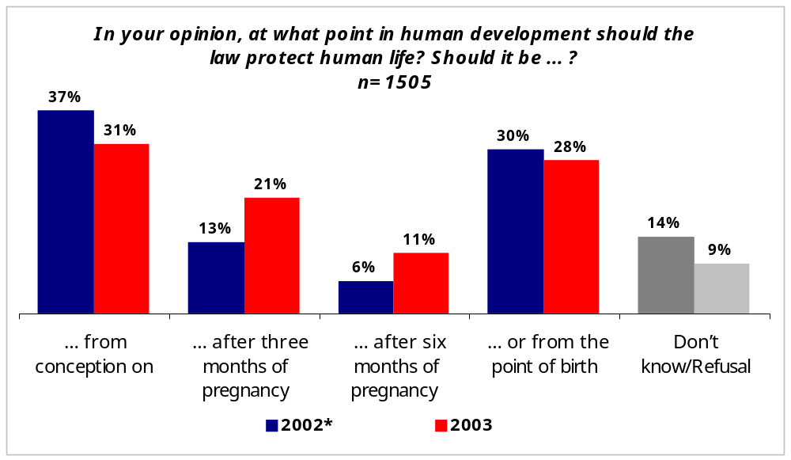

*Source: Leger Marketing national omnibus survey, October 2002. 1501 respondents representative of the C%anadian population. Maximum margin of error of ±2.5%

Respondents with the following characteristics are significantly more likely to believe that the law should protect human life …

- … from conception on: women (37%), English-speaking respondents (33%), respondents from the Prairies (40%) and Alberta (39%), respondents with an annual household income of less than $20K (38%), homemakers (48%) and respondents with a high school level of education (37%).

- … after three months of pregnancy: 25-34 yearolds (29%), respondents with a university level of education (27%).

- … after six months of pregnancy: Respondents with an annual household income of $60K or more (14%), professionals (17%).

- … from the point of birth: men (33%), French-speaking respondents (34%), respondents from Quebec (35%), respondents with an annual household income between $20K and $40K (33%), unemployed respondents (42%) and respondents with a elementary level of education (44%).

Results by Province

In your opinion, at what point in human development should the law protect human life? Should it be ... ?

 | Total (n=1505) | Atl. (n=100) | Quebec (n=400) | Ontario (n=605) | Prairies (n=125) | Alberta (n=125) | B.C.  (n=150)
- … from conception on | 31% | 34% | 26% | 32% | 40% | 39% | 29%
- … after three months of pregnancy | 21% | 22% | 22% | 21% | 19% | 19% | 21%
- … after six months of pregnancy | 11% | 11% | 11% | 9% | 11% | 11% | 13%
- … or from the point of birth | 28% | 23% | 35% | 29% | 17% | 21% | 28%
- Don’t know/Refusal | 9% | 11% | 6% | 9% | 11% | 9% | 9%

3. The Use of Human Embryos in Stem Cells Research

When informed that it is possible to conduct medical research using stem cells from either human embryos or other sources, and that in the case of human embryos, the research involves the destruction of these embryos, 21% of Canadians consider that it is equally acceptable to carry out research using stem cells from human embryos or other sources. A proportion of 37% believe that it is preferable to use other sources beside human embryos, while 33% think that it is not acceptable to carry out research that involves the destruction of human embryos.

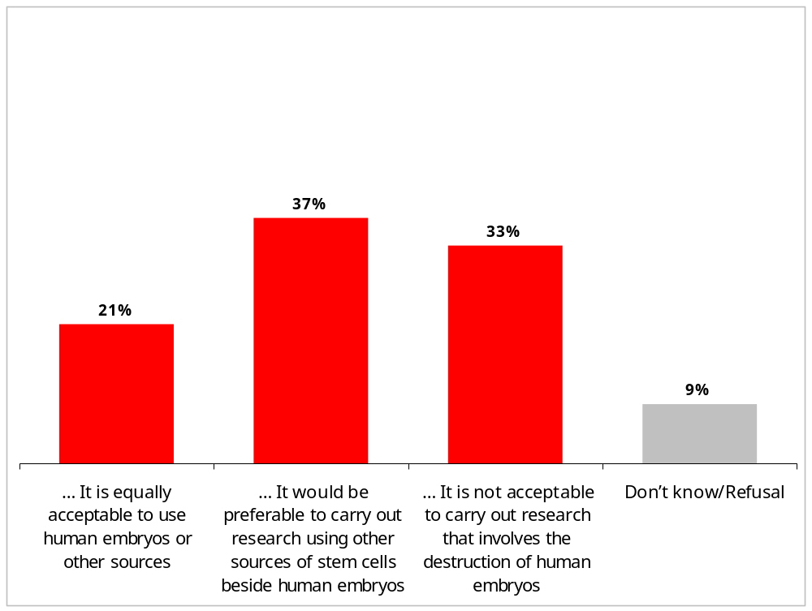
Legislation is now before Parliament that would allow medical research using stem cells from human embryos. This research would involve the destruction of the embryos used. Stem cell research using other sources such as adult tissue or umbilical cord blood does not involve loss of life or other harm. Which of the following statements most closely represents your own opinion?
n=1505
Respondents with the following characteristics are significantly more likely to believe that …

- … it is equally acceptable to use human embryos or other sources: 18-24 yearolds (27%), respondents from Ontario (25%), students (33%).

- … it would be preferable to carry out research using other sources of stem cells beside human embryos: English-speaking respondents (39%), professionals (42%), respondents with a university level of education (43%).

- … it is not acceptable to carry out research that involves the destruction of human embryos: women (36%), 45-54 yearolds (38%), French-speaking respondents (38%), respondents from Quebec (38%), manual workers (42%), respondents with a high school level of education (39%).

Results by Province

Legislation is now before Parliament that would allow medical research using stem cells from human embryos. This research would involve the destruction of the embryos used. Stem cell research using other sources such as adult tissue or umbilical cord blood does not involve loss of life or other harm. Which of the following statements most closely represents your own opinion?

 | Total (n=1505) | Atl. (n=100) | Quebec (n=400) | Ontario (n=605) | Prairies (n=125) | Alberta (n=125) | B.C.  (n=150)
… It is equally acceptable to use human embryos or other sources | 21% | 12% | 19% | 25% | 18% | 22% | 19%
… It would be preferable to carry out research using other sources of stem cells beside human embryos | 37% | 45% | 34% | 35% | 39% | 40% | 38%
… It is not acceptable to carry out research that involves the destruction of human embryos | 33% | 34% | 38% | 31% | 35% | 33% | 31%
Don’t know/Refusal | 9% | 9% | 9% | 10% | 8% | 6% | 12%

4. Consent Laws on Abortion

In total, over two-thirds of Canadians (69%) would support consent laws on abortion that would be similar to those informed recently in some states of the US, that is, they require that before a woman has an abortion procedure, her physician must provide her with certain information such as details on the stages of fœtal development including an ultrasound scan, possible complications and side effects following an abortion, and alternatives to abortion.
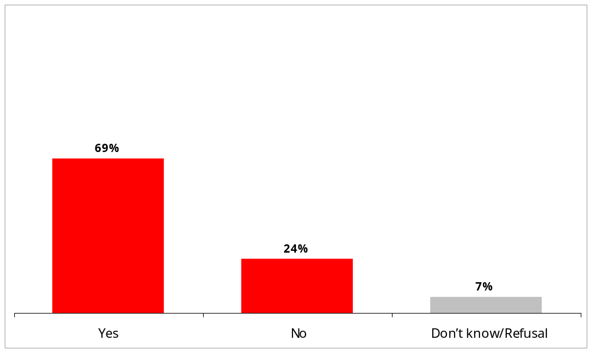
Some states in the US have informed consent laws concerning abortion. These laws require that before a woman has an abortion procedure, her physician must provide her with certain information such as details on the stages of foetal development including an ultrasound scan, possible complications and side effects following an abortion, and alternatives to abortion. Would you support similar laws in Canada for women considering abortion?
n=1882

Respondents with the following characteristics would significantly more likely …

- … support such laws : 18-24 yearolds (78%), office workers (74%), students (78%).

- … NOT support such laws: professionals (28%), homemakers (31%), respondents with an elementary level of education (35%).

Results by Province

 | Total (n=1882) | Atl. (n=200) | Quebec (n=400) | Ontario (n=605) | Prairies (n=125) | Alberta (n=252) | B.C.  (n=300)
- Would support | 69% | 71% | 71% | 65% | 72% | 72% | 70%
- Would not support | 24% | 24% | 22% | 24% | 21% | 23% | 24%
- Don’t know/Refusal | 7% | 5% | 6% | 11% | 7% | 7% | 6%

5. Parents Consent For Abortion

The Canadian population seems relatively divided on the issue of parents consent regarding abortion. In fact, just over one third (35%) believe that parents should be only be notified if their minor child wanted an abortion, while another third (32%) believe that parents should be notified and give consent, and close to one-third as well (27%) think that parents need not be notified or give consent.

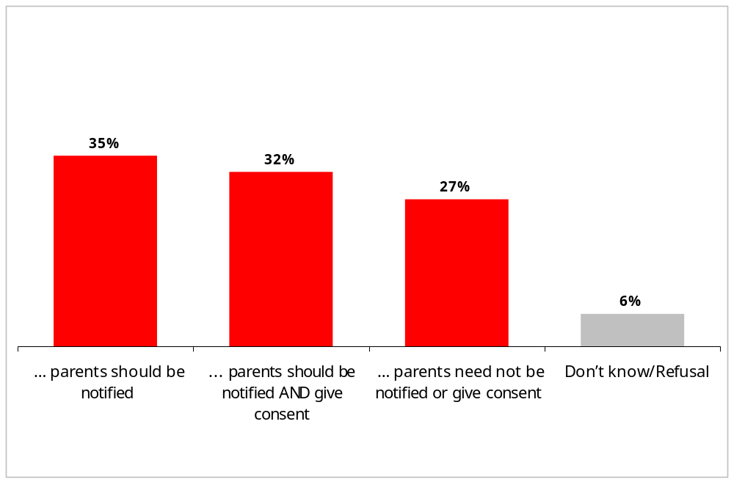
At present in Canada it is legal for a minor under the age of 18 to have an abortion without the knowledge or consent of parents. Do you think that the law should require that before a minor under the age of 18 can obtain an abortion, parents be notified and give consent ? Do you think that ... ?
n=1882

Respondents with the following characteristics are significantly more likely to believe that …

- … parents should be notified: 65 years of age or older (41%), respondents speaking another language than English or French (41%), retirees (40%).

- … parents should be notified and give consent: English-speaking respondents (34%), respondents from the Atlantic provinces (42%), respondents with an annual household income between $20K and $40K (37%), homemakers (48%), respondents with a high school level of education (36%).

- … parents need not be notified or give consent: 18-24 yearolds (37%), French-speaking respondents (35%), respondents from Quebec (39%), respondents with an annual household income over $60K (34%), professionals (37%), students (38%), respondents with a college (30%) or university (33%) level of education.

Results by Province

At present in Canada it is legal for a minor under the age of 18 to have an abortion without the knowledge or consent of parents. Do you think that the law should require that before a minor under the age of 18 can obtain an abortion, parents be notified and give consent ? Do you think that ... ?

 | Total (n=1882) | Atl. (n=200) | Quebec (n=400) | Ontario (n=605) | Prairies (n=125) | Alberta (n=252) | B.C.  (n=300)
- … parents should be notified | 35% | 34% | 33% | 34% | 36% | 37% | 37%
- .. parents should be notified AND give consent | 32% | 42% | 24% | 34% | 34% | 36% | 28%
- … parents need not be notified or give consent | 27% | 18% | 39% | 24% | 20% | 21% | 29%
- Don’t know/Refusal | 6% | 7% | 4% | 7% | 9% | 6% | 6%

6. Opinion of Canadians toward the Use of Public Funds for Abortions

Opinions of Canadians toward the use of public funds for abortions has not changed since last year. Half of Canadians (53%) still think abortion should be financed through taxes but only in case of medical emergencies such as, a threat to the mother’s life or in the case of rape or incest. Only 25% indicate that abortion should always be financed by health-funded tax system and even fewer (15%) think that abortion should be a private responsibility (including Blue Cross or other private health plans).
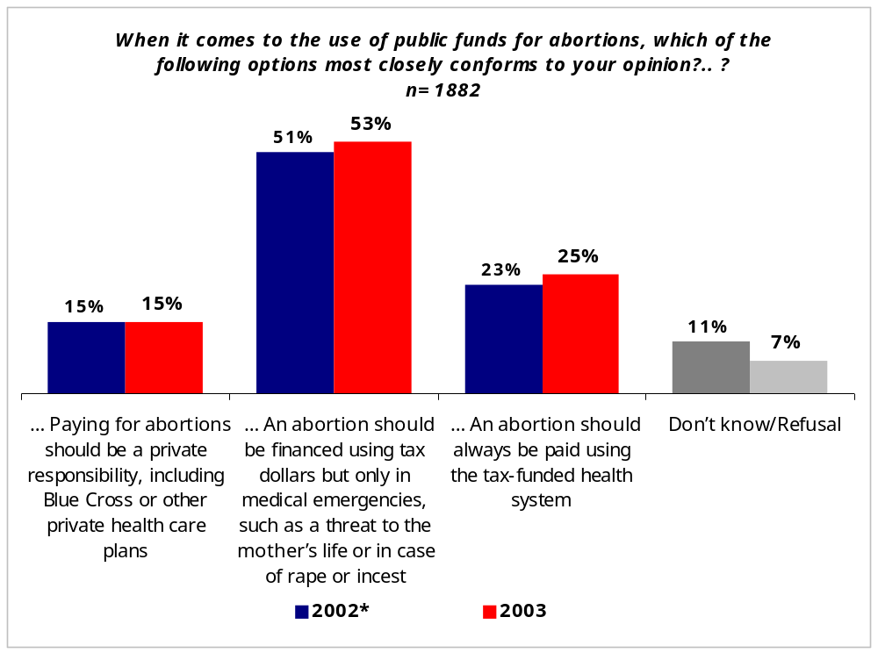

*Source: Leger Marketing national omnibus survey, October 2002. 3510 respondents representative of the C%anadian population. Maximum margin of error of ±1.8%

Respondents with the following characteristics are significantly more likely to believe that …

- … abortion should always be a private responsibility: respondents with an annual household income between $20K and $40K (17%), homemakers (23%).

- … abortion should be paid by tax dollars only in case of medical emergencies : respondents from the Prairies (62%), manual workers (61%).

- … abortion should always be paid with tax dollars: 55-64 yearolds (30%), French-speaking respondents (29%), respondents from Quebec (33%), respondents with an annual household income of $60K or more (32%), professionals (32%), respondents with a university level of education (31%).

Results by Province

When it comes to the use of public funds for abortions, which of the following options most closely conforms to your opinion?

 | Total (n=1882) | Atl. (n=200) | Quebec (n=400) | Ontario (n=605) | Prairies (n=125) | Alberta (n=252) | B.C.  (n=300)
… Paying for abortions should be a private responsibility, including Blue Cross or other private health care plans | 15% | 16% | 12% | 17% | 13% | 19% | 14%
… An abortion should be financed using tax dollars but only in medical emergencies, such as a threat to the mother’s life or in case of rape or incest | 53% | 57% | 48% | 53% | 62% | 57% | 50%
… An abortion should always be paid using the tax-funded health system | 25% | 21% | 33% | 24% | 17% | 19% | 27%
Don’t know/Refusal | 7% | 6% | 7% | 7% | 9% | 5% | 9%

Questionnaire

QL1
QL1. In your view, when did your own life begin? Was it ...
LIRE
... at conception 1
... at birth 2
... Sometime between conception and birth 3
... After birth 4
Dont't know 8
Refusal 9
«QL1 »

QL2
QL2. In your opinion, at what point in human development should the law protect human life? Should it be ... ?
... from conception on 1
... after three months of pregnancy 2
... after six months of pregnancy 3
... or from the point of birth 4
Don't know 8
Refusal 9
«QL2 »

QL3. Legislation is now before Parliament that would allow medical research
using stem cells from human embryos. This research would involve the
destruction of the embryos used. Stem cell research using other sources
such as adult tissue or umbilical cord blood does not involve loss of
life or other harm. Which of the following statements most closely
represents your own opinion?

(1) ... It is equally acceptable to use human embryos or other sources
(2) ... It would be preferable to carry out research using other sources of
stem cells beside human embryos
(3) ... It is not acceptable to carry out research that involves the
destruction of human embryos
(8) Don't know
(9) Refusal

'F1' TO SEE CODES @QL3

QL4. Some states in the US have informed consent laws concerning
abortion. These laws require that before a woman has an abortion
procedure, her physician must provide her with certain information
such as details on the stages of fetal development including an
ultrasound scan, possible complications and side effects following
an abortion, and alternatives to abortion. Would you support
similar laws in Canada for women considering abortion?

(1) ... Yes
(2) ... No
(8) Don't know
(9) Refusal 'F1' TO SEE CODES @QL4

QL5
QL5. At present in Canada it is legal for a minor under the age of 18 to have an abortion without the knowledge or consent of parents. Do you think that the law should require that before a minor under the age of 18 can obtain an abortion, parents be notified and give consent ? Do you think that ... ?
LIRE
... parents should be notified 1
... parents should be notified AND give consent 2
... parents need not be notified or give consent 3
Don't know 8
Refusal 9
«QL5 »

QL6. When it comes to the use of public funds for abortions, which of the
following options most closely conforms to your opinion?

(1) ... Paying for abortions should be a private responsibility,including
Blue Cross or other private health care plans
(2) ... An abortion should be financed using tax dollars but only in
medical emergencies, such as a threat to the mother's life or in
case of rape or incest
(3) ... An abortion should always be paid using the tax-funded health
system
(8) Don't know
(9) Refusal

'F1' TO SEE CODES @QL6

